**PRIVATE LIVES: THE ARTIST AS COLLECTOR**

24 January – 22 February 2015

This is the first exhibition to present the fascinating personal collections of leading contemporary artists including Wendy Sharpe and Bernard Ollis, Michael Kempson, Leo Robba and Adrienne Roberts, Peter Sharp, Euan Macleod, and Henry Mulholland.

From mass-produced memorabilia, one-of-a-kind curiosities and rarefied artefacts, these collections provide insight into the inspirations, influences, motives and obsessions of artists. It is not uncommon for artists to conduct ‘swaps’ with their contemporaries as an affordable way of building their own collections and supporting each other, thus this exhibition also highlights some exchanges that have taken place over the years between artists.

While some artists are connoisseurs, others accumulate so many objects it is impossible to hang them all. Inspired by the artist collectors such as Picasso, who famously 'borrowed' objects from the Louvre, this exhibition allows visitors a glimpse into the private world of the artist and their inspiration.

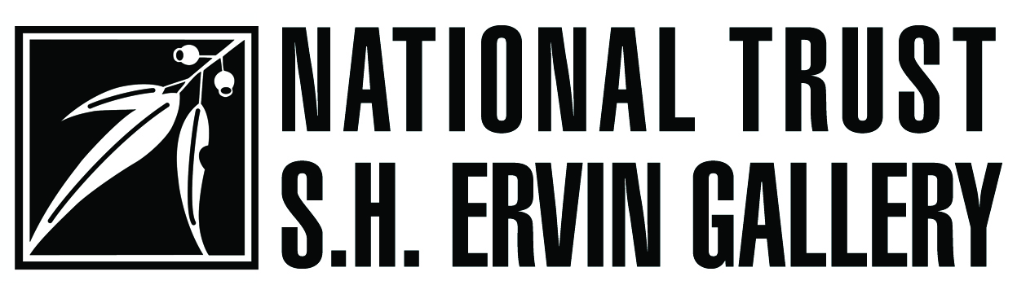

**EUAN MACLEOD COLLECTION**

Euan Macleod was born Christchurch, New Zealand, 1956. He completed a Certificate in Graphic Design at Christchurch Technical Institute 1974-75 and a Diploma of Fine Arts (Painting) at the Canterbury University, Christchurch,1977 - 1979. He moved to Sydney in 1981 and has lived and has consistently exhibited since 1980, having held his first solo exhibition in 1982 at Watters Gallery in Sydney. Macleod has been the recipient of many prestigious awards such as the 1999 Archibald Prize, the 2001 Sulman Prize, the 2006 Blake Prize and most recently the 2009 Gallipoli Art Prize.

Macleod’s work is concerned with the natural landscape and human presence within it. His dense, textured and sculptural use of paint has become a consistent feature of his work.

Many of his landscapes are not specifically Australian or that of New Zealand, but composites, further heightening their psychological impact.His expressive style lends itself to simple yet potent compositions, his muted palette imbuing the works with rich symbolism and atmosphere. His use of colour has expanded in the last decade, with many works depicting the ochres and crimsons of the Australian desert.

Euan Macleod is represented by Watters Gallery.

**ABOUT HIS COLLECTION**

“The collection has grown after realising how much more I enjoyed living with others work than my own. I need to look critically at my own and prefer to dwell on what I'm currently working on in the studio.

I'm incredibly lucky to know most of the people who have made the things in our house and this adds greatly to my connection and enjoyment of it. Our friends.”

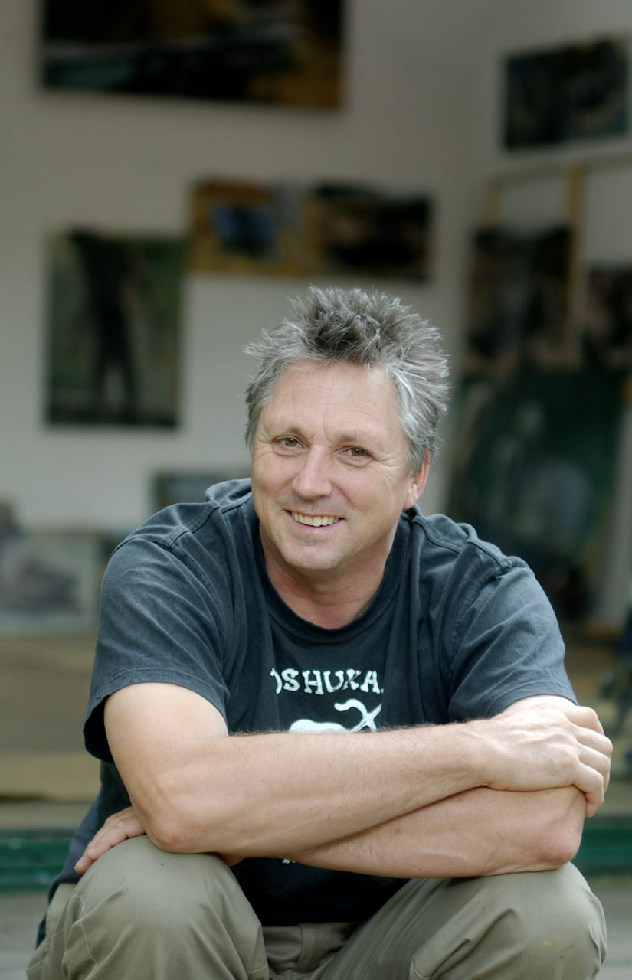

**image courtesy Sydney Morning Herald, 2014**

4.

1.

5.

3.

2.

**1. LEON GOLUB   
*Riot*** undated print

**2. KEVIN LINCOLN   
*Self portrait and tube*** 1996 oil on linen

**3. CHAS GLOVER   
*Number 3*** 2010 acrylic on canvas

**4. FIONA HALL   
*21st century man*** 2011 US currency on paper

**5. MICHAEL KEMPSON  
*The critic*** 2006 etching

6.

7.

10.

11.

9.

8.

12.

**6. JOANNA BRAITHWAITE   
*Longshot*** 2009 oil on canvas

**7. CHAS GLOVER   
*Untitled*** 2013 acrylic on canvas

**8. NOEL McKENNA   
*Oriental Bay Wellington*** 2012 oil/acrylic on ply

**9. GEOFF DIXON   
*House*** 1995 oil on board

**10. TONY TUCKSON   
*TP318*** circa 1952-56 oil on canvas

**11. ADRIENNE RICHARDS   
*Wrapped traveler 3*** 1996 oil on canvas

**12. DON PEEBLES   
*Fragment from a journey*** 2004 acrylic and charcoal on ply

17.

16.

13.

14.

18.

15.

20.

19.

**13. STEVE LOPES   
*Euan painting*** 2013 oil on canvas

**14. TELLY TU’U   
*We/Me*** 2014 oil on board

**15. TOSS WOOLLASTON  
*Landscape with pond in the  
Takaka Valley*** 1962 ink on paper

**16. CHAS GLOVER   
*Acrobats*** 2003 acrylic on canvas

**17. LEO ROBBA   
*3 velvet trees/Bundanon*** 2003 oil on canvas

**18. WILLIAM SUTTON   
*Untitled*** 1993 watercolour on paper

**19. ALISON MACKAY   
*Composition II*** undated oil on canvas

**20. TOM CARMENT   
*Untitled (beach)*** undated oil on panel

24.

21.

25.

22.

23.

**21. CHRIS O’DOHERTY aka  
REG MOMBASSA   
*Sun proof cloud, Maria Island*** 2007 coloured pencil on paper   
   
**22. JASPER LEGGE   
*Untitled*** 2009 oil on plastic pinned to board   
   
**23. ELISABETH CUMMINGS   
*Wedderburn bush table*** 2010/11 oil on canvas   
  
**24. FRANK LITTLER   
*Bike in shadow of bicycle*** 2011 oil on hardboard   
  
**25. RALPH HOTERE   
*Winter solstice*** 1991 print

28.

27.

26.

**26. JULIE HARRIS   
*Untitled*** 2001 acrylic on paper

**27. ROSS LAURIE   
*Fowlers Gap I*** 2011 oil on paper

**28. RON McBURNIE   
*Winter light*** 2011 etching

**SCULPTURAL WORKS FROM LEFT TO RIGHT**

**OLIFFE RICHMOND   
*Lizardman, variation II***bronze

Collection: Euan Macleod

**JAN KING   
*Untitled (still life)*** 2010 welded steel

Collection: Euan Macleod

**PAUL SELWOOD   
*Untitled*** undated brazed steel

Collection: Euan Macleod

**INDIVIDUAL WORKS AT GALLERY ENTRANCE AND IN RIGHT BAY**

**ALISON CLOUSTON   
*Copperhead*** undated cattle hide, watercolour, and ink

Collection: Euan Macleod

**BEN QUILTY   
*Self portrait after Afghanistan with beard  
and red cap*** undated oil on canvas

Collection: Euan Macleod

**KEN WHISSON   
*Summer solstice*** 1988 oil on canvas

Collection: Euan Macleod

**RICHARD LARTER   
*Power blow*** 1974 acrylic on canvas

Collection: Euan Macleod

**PETER SHARP COLLECTION**

Peter Sharp was born in Sydney in 1964. He completed a Bachelor of Art Education at City Art Institute, Sydney in 1987 before graduating with a Masters of Fine Art at the University of New South Wales, College of Fine Arts in 1992. From 1989-1999, Sharp held regular solo exhibitions at Coventry Gallery, Sydney. In 1997 he was  granted a residency at the Cite des Arts Internationale In 1999, he was invited to exhibit at Kunstraum 34 in Stuttgart, Germany. In 2001, Sharp participated in the award winning television documentary Two-Thirds Sky. His paintings have been exhibited in the Wynne Prize (1996, 2003), the Sulman Prize (1998, 2008) and the Dobell Prize for Drawing (2009, 2010) at the Art Gallery of New South Wales. In 2009, Sharp was invited to be part of the Taronga Zoo Artist-in-Residence program which was featured on the ABC.  
  
In 2011, Artist Profile magazine sponsored a group of 13 artists including Peter Sharp to travel to Fowler's Gap in far western NSW and respond to their surrounding landscape in a body of work. Curated by Owen Craven and in association with Winsor & Newton, Not the Way Home, an exhibition of the artists' work was exhibited at S.H Ervin Gallery, The National Trust, NERAM, and Broken Hill City Art Gallery in 2012.

Sharp has exhibited widely in group exhibitions including: Insight Radical: Where Science Meets Art at Griffin Gallery, London (2013), Personal Space: Contemporary Chinese and Australian Prints, Manly Art Gallery and Museum, Sydney (2011), Artist Artists, Benalla Art Gallery, Victoria (2011), Silk and Sand: Chinese and Australian Prints, Ivan Dougherty Gallery, University of New South Wales, Sydney; The Central Academy of Fine Arts, Beijing, China (2008) and Contemporaneous: Australian Contemporary Painting 1, Wangaratta Art Gallery, Victoria (2008). Sharp was selected for the Salon des Refuses at the S. H. Ervin Gallery, in 2013 and in 2014. Sharp is also in the inaugural Dobell Australian Drawing Biennial - Drawing Out -  at the Art Gallery of New South Wales, curated by Anne Ryan.  
  
In 2012, Sharp held his first survey at Hazelhurst Regional Gallery and Arts Centre titled Peter Sharp: Will to Form, curated by Liz Nowell and featured works from over a 15 year period. This survey also culminated in the publication Peter Sharp: Will to Form, a 120 page fully illustrated hardback catalogue, which includes essays by Andrew Frost and Gillian Serisier.  
  
Peter Sharp lives and works in Sydney and is represented by Liverpool Street Gallery.

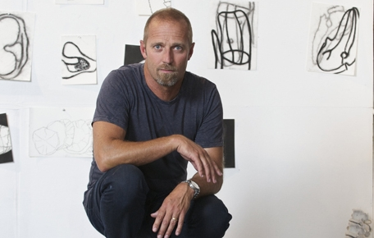**image courtesy University of New South Wales, 2012**

1.

3.

5.

7.

2.

4.

6.

8.

9.

**1. JOE FROST  
*Ships, Walsh Bay*** 2005 graphite on paper   
  
**2. PETER BOOTH  
*Untitled*** undated oil pastel, crayon on paper

**3. MARC ETHERINGTON  
*Kapow*** 2013acrylic on paper

**4. ILDIKO KOVACS  
*Untitled*** 2000 oil on canvas

**5. PETER SHARP  
*Bimble box*** 2014oil and acrylic on linen panel

**6. ROB McHAFFIE  
*Untitled*** 2014collage on paper

**7. STEVEN HARVEY  
*Untitled*** undated charcoal on paper

**8. MARC ETHERINGTON  
*Toe and soc*** 2013acrylic on board

**9. PAUL WILLIAMS  
*Things about*** 2009pencil on paper

10.

11.

16.

13.

12.

14.

15.

**10. MICHELLE CAWTHORNE  
*Kite*** 2011ink and collage on paper   
  
**11. SHALINI JARDIN  
*Untitled (frogs)*** undatedgouache/ink on paper

**12. SALLY SMART  
*Family tree*** 2003As part of *Family tree* series 1999 – 2003

synthetic flock on canvas with wooden stretcher   
  
**13. GODFREY MILLER  
*Untitled*** undated pencil on paper

**14. ANDREW   
CHRISTOPHEIDES  
*Realisation*** 2002print   
 **15. STEVE POWER   
aka ESPO  
*Everything is shit***  2013silkscreen  
 **16. PHYLLIS THOMAS  
*Boil dreaming, Fitzroy   
crossing*** undated print

**SCULPTURAL WORKS FROM LEFT TO RIGHT**

**CATHERINE HEARSE  
*Untitled*** undated wood and cotton

Collection: Peter Sharp  
  
**JOHN TURIER  
*Beast*** undated wood and steel

Collection: Peter Sharp   
  
**FIONA HALL  
*Rising tide*** undated glass and plastic

Collection: Peter Sharp

**INDIVIDUAL WORKS IN RIGHT BAY AND BACK WALL**

**IDRIS MURPHY  
*Untitled*** 2013acrylic on board

Collection: Peter Sharp

**PADDY BEDFORD  
*Untitled*** undated acrylic on paper

Collection: Peter Sharp

**TIMOTHY COOK  
 *Kulama*** 2012 natural ochres on paper

Collection: Peter Sharp

**JAMES POWDITCH COLLECTION**

James Powditch is a mixed media artist with a background in set building for the Sydney Theatre Company and Sydney Dance Company. He is a 4 times Archibald Prize finalist, last year with a portrait of Nick Cave and is a current Doug Moran Portrait Prize finalist with a portrait of artist Ben Quilty. He is a past winner of the Mosman Art Prize and the Blake Prize for Religious Art, a many times finalist in the Wynne and Sulman Prizes (AGNSW) and the Salon de Refusés (S.H. Ervin Gallery) amongst many others. His work is heavily influenced by cinema, architecture, science and politics. He held his first exhibition with friend Rodney Simmons at Tap Gallery, Sydney in 1997 having met at City Art Institute (now COFA) in 1985.  
  
James Powditch is represented by Gallery Ecosse.

**ABOUT HIS COLLECTION**

‘I'm an opportunistic/obsessive collector of art and stuff in general, things I love often by people I love. My own work is 'built' from stuff and I've always got an eye out for the unusual.... I've always been surrounded by art through my father, artist Peter Powditch and my mother, her father, John Magrath was a 'Sunday painter'. Our homes were always full of their work, walls just had to be full! Early on I collected film posters and still do. And then later as I started to make art in the late 1990's I began to swap with friends and when I had the cash I would buy works, often from artists early shows. Lately I've been on an art swap frenzy with other artists, enabling me to get some major works I could never afford to buy, art as currency!  There is no rationale to the collection but it leans towards the bold and graphic with a definite Pop sensibility.’

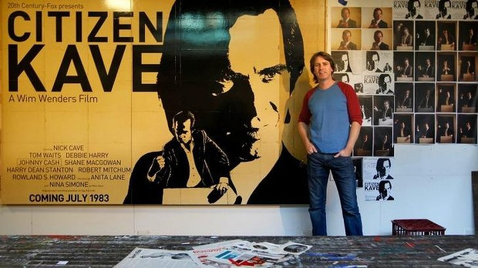

**image courtesy Sydney Morning Herald, 2014**

4.

1.

5.

3.

2.

**1. PETER GODWIN  
*Owl with spirit mask 2*** 2002 egg tempera on hemp on marine ply

**2. STEVEN SEIWERT   
*Newtown RSL*** undated photograph

**3. McLEAN EDWARDS   
*Untitled*** undatedoil on canvas

**4. JOHN MAGRATH  
*Untitled*** undated gouache

**5. FRANCK GOHIER  
*Suzie - 2*** 2005 mixed media assemblage

**INDIVIDUAL SCULPTURES**

**ANGUS ADAMEITIS  
*Untitled*** undatedbronze metal

**TIM KYLE  
*Euan Macleod*** undatedoil and wire sculpture

9.

8.

6.

10.

7.

**6. PAUL RYAN   
*Portrait of Adam Cullen*** 2013 oil and oil stick on canvas   
 **7. ORIGINAL CUBAN FILM POSTER  
*Cool hand Luke*** 1975poster print   
 **8. ORIGINAL ITALIAN FILM POSTER  
*Once upon a time in the West*** 1968poster print   
 **9. NIKE SAVVAS   
*Untitled*** undated print   
 **10. TON TIMMERS  
*Untitled*** 2010acrylic on board  
 **11. LUCY CULLITON  
*Untitled (watermelon)*** undatedoil on canvas

11.

20.

16.

19.

17.

12.

21.

15.

13.

18.

14.

**12. JOE WILSON  
*Cranes at Cockatoo Island*** undatedcharcoal on paper

**13. DARREN McDONALD  
*Black buck*** 2003acrylic on canvas

**14. MARTIN SHARP  
*Question*** undated acrylic on paper

**15. PAUL WORSTEAD  
*One more day on earth*** undatedacrylic on board

**16. RODNEY SIMMONS  
*Prague*** 2008pencil, charcoal, gouache, and acrylic on paper

**17. PETER POWDITCH  
*Untitled (nude)*** 1966acrylic assemblage on board

**18. REG LYNCH  
*It’s a guitar shaped world*** 1998poster print

**19. PETER O’DOHERTY  
*Civic hotel*** 1999 oil on canvas

**20. CHANTELLE CHELLIER  
*Bibliotheken Baven II 2013***print

**21. DEAN MANNING  
*Golden gift*** undatedacrylic on board

**WENDY SHARPE AND BERNARD OLLIS COLLECTION**

**WENDY SHARPE** Wendy Sharpe (b. 1960) lives and works in Sydney and Paris. She has won many major national awards, scholarships and prizes including the Sulman Prize, Marten Bequest Travelling Scholarship, Portia Geach Memorial Award (twice), the Archibald Prize and many others. Major commissions include , Olympic  pool size mural for Cook and Philip Park Aquatic Centre, Sydney, a commission by the Australian War Memorial, as an Australian Official Artist to East Timor 1999, and a commission from the Art Centre Victoria to draw the Australian ballet. She has also been awarded artist residencies in Paris, Egypt, Mexico and two in Antarctica.   
  
Wendy Sharpe is represented in Sydney by King Street Gallery on William.

**BERNARD OLLIS** Bernard Ollis (b. 1951) has been exhibiting since 1973. He is a graduate of Cardiff College of Art and the Royal College of Art, London where he was tutored by David Hockney, Peter Blake and R.B Kitaj. He came to Australia in 1976 where he taught at Charles Darwin and La Trobe Universities and was the director of the National Art School Sydney from 1996 to 2008.

Ollis has held over 50 solo exhibitions in Australia, Britain, France and New Zealand and his work is in the permanent collections of many state and regional galleries worldwide including the Royal College of Art London and the National Gallery Canberra. Ollis has been a multiple finalist in many major prizes and won the Gold Coast Prize, Queensland and the John Minton Prize, London. He has been awarded artists residencies in Paris, Egypt and recently, in Antarctica.   
  
Bernard Ollis is represented in Sydney by NG Art Gallery, Chippendale.

**ABOUT THEIR COLLECTION**This idiosyncratic collection of objects, paintings, drawings, textiles, and sculptures, has been collected over many years. Some were acquired during our many trips overseas from places as diverse as Syria and Mexico through to Laos and Sri Lanka, and yet some of the most exotic looking things were bought in Newtown!

Among the collection are many ‘swaps’ and presents from other artists, as well as a big collection of Papua New Guinea sculpture. We are both interested in folk art and our house is crowded with a diverse range of objects. They act as reminders of past experiences and also act as catalysts for new concepts in own work, and in this way they inhabit both the house and our studios in Sydney.

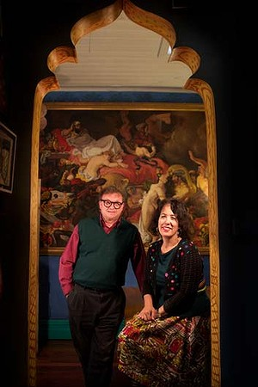

**image courtesy Sydney Morning Herald**

3.

4.

1.

6.

7.

2.

8.

5.

**1. KEVIN CONNOR  
*Untitled*** 2004gouache on paper

**2. PAUL THOMAS  
*Cautionary tale involving bees*** undated pencil drawing

**3. ANITA TAYLOR  
*Untitled*** undatedink drawing

**4. IVOR HELE  
*‘er bum*** 1966pencil sketch on paper

**5. DANIEL PATA  
*Musee Rodin*** 1995pencil drawing on paper

**6. TIM SCHULTZ  
*Wendy*** 1993charcoal sketch on paper

**7. NORA HEYSEN  
*Ashley’s wife*** undated red chalk and pastel sketch on paper

**8. R. ZIN  
*Wendy as model*** 1979charcoal and pastel sketch on paper

9.

10.

12.

13.

11.

**9. ARTHUR BOYD  
*Expulsion from the garden of Eden*** undatedcoloured etching

**10. UNKNOWN VIETNAMESE ARTIST  
*Village scene*** undatedembroidered silk

**11. TANIA CASTAING  
*Annie, Wendy, and Simon*** 1991 linocut

**12. GARRY SHEAD  
*Springwood I*** undated etching

**13. GARRY SHEAD  
*Springwood II*** undated etching

19.

18.

15.

16.

14.

20.

17.

**14. UNKNOWN ABORIGINAL  
PAINTER (Northern Territory)  
*Untitled*** circa 1970painted bark

**15. SIMON MARK  
*Washing line and tree*** undated oil on canvas

**16. MARYANNE COUTTS  
*Untitled*** undated collage and paint on paper

**17. VANESSA OLLIS  
*Pig*** undated acrylic on canvas

**19. ELISABETH CUMMINGS  
*Still life at window*** 2004oil on canvas

**18. SHONA TRESCOTT  
*Fish still life*** 2003oil on canvas

**20. UNKNOWN MEXICAN ARTIST   
*Retablo*** undatedpaint on tin

26.

26.

25.

22.

21.

26.

24.

23.

26.

**21. JASON BROOKS  
*Offspinner*** undatedacrylic on canvas

**22. ROBERT JACKS  
*Death in the afternoon*** 2005oil on canvas

**23. STEPHEN FARTHING  
*Malta #6*** 2005oil on canvas

**24. JOHN BARTHOLOMEW  
*The purple moon’s transparent nightie*** 2010assemblage sculpture

**25. EUAN MACLEOD  
*Big legs 2*** 1998oil on canvas   
 **26. UNKNOWN INDIAN MINIATURIST  
*Four Persian-style miniatures*** undated gouache

**OBJECTS FROM LEFT TO RIGHT**

**SEPIK RIVER REGION MASK  
*Untitled*** undated coconut shell with clay, shells, and feathers

**JANNA FERRIS  
*Nipple plate*** undatedpainted glazed ceramic

**UNKNOWN INDIAN ARTIST  
*2 masks, 1 man, 1 woman*** undatedpainted paper mache masks

**MYFANNY, MADELEINE, AND VANESSA OLLIS  
*Happy Birthday, Dad*** undated photomontage

**MADELEINE OLLIS  
*Roxy*** undated painted ceramic figure

Collection: Wendy Sharpe and Bernard Ollis

**UNKNOWN AUSTRALIAN ARTIST  
*Swan lake*** undatedcrocheted acrylic wool

**INDIVIDUAL SCULPTURES**

**UNKNOWN AFRICAN SCULPTOR  
*Crouching creature*** undatedpainted wood

Collection: Wendy Sharpe and Bernard Ollis

**UNKNOWN AFRICAN SCULPTOR  
*3 figures – man, woman, doctor*** undatedpainted wood

Collection: Wendy Sharpe and Bernard Ollis

**UNKNOWN MEXICAN SCULPTOR  
*Nurbert and Hubert*** undated paper mache painted skeletons

Collection: Wendy Sharpe and Bernard Ollis

**UNKNOWN NEW GUINEAN SCULPTOR  
*Ancestor figure as roof finial*** undatedpainted wood

Collection: Wendy Sharpe and Bernard Ollis

**LEO ROBBA AND ADRIENNE RICHARDS COLLECTION**

**LEO ROBBA**

Leo Robba (b. 1962) is an artist, writer and curator born in Bundaberg, Queensland. Since graduating from the Queensland College of Art in 1982 and moving to Sydney he has held over thirty-five solo exhibitions in Australia and New Zealand and has taken part in numerous group exhibitions nationally and internationally.

Leo has a Masters of Fine Art from Newcastle University exploring the topic ‘Regionalism in Australian Landscape Painting’ and is currently doing research as part of his PhD scholarship at the ANU, Canberra, on the topic ‘The Artist’s Garden: Humanising the Landscape.’  
  
Leo is represented in Sydney by King Street Gallery on William.

**ADRIENNE RICHARDS**

Adrienne Richards has a deep love and knowledge of the visual arts. Having studied Fine Art at the Canberra School of Art, ANU, Canberra, she majored in Visual Communications and has since had several solo exhibitions of her paintings. Additionally, Richards has been included in numerous group exhibitions such as ‘On The Heysen Trail’ at S.H. Ervin Gallery and a regional touring exhibition ‘In Two Art,’ initiated by Maitland Regional Gallery.

**ABOUT THEIR COLLECTION**

Leo and Adrienne live and work in Springwood, in the Blue Mountains with their two children.

“Our collection is a big part of our lives, there is no strategy, it’s not about money … it is about living with beautiful things made by people who view the world in their own special way. Most of the works in the collection are by artist friends, so it’s like living in a big shared house but without all the drama.”

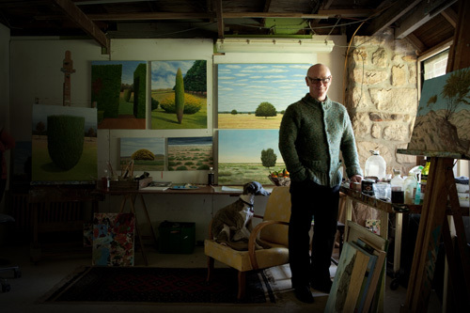

**Leo Robba in the studio, image courtesy Good Weekend magazine, 2012**

5.

1.

7.

6.

4.

2.

3.

**1. PETER TILLY  
*Left after loss*** 1999bone, lead and timber   
  
**2. CHRIS O’DOHERTY   
aka REG MOMBASSA   
*Study for self portrait*** 2004 acrylic on paper

**3. CHRIS O’DOHERTY   
aka REG MOMBASSA   
*Coalition Victory Celebration*** undated coloured pencil on paper   
 **4. LUCY CULLITON  
*Veggie plate*** 1988 oil on board

**5. FRANK LITTLER  
*Spider car*** 1997 oil on board

**6. LOUISE KERR   
*Untitled***  undated mixed media

**7. ROBERT MACLEOD   
*Untitled*** undated oil on board

11.

16.

15.

8.

9.

10.

17.

12.

13.

18.

14.

**8. ROY JACKSON  
*Blue visitor*** 1994 oil on board

**9. CHRIS O’DOHERTY   
aka REG MOMBASSA  
*Leo at Glen Helen*** undated charcoal on paper

**10. JO BRAITHWAITE  
*Untitled (whale painting)*** 2001 oil on canvas

**11. ELISABETH CUMMINGS  
*Untitled*** undated oil on canvas

**12. JO BRAITHWAITE  
*Untitled (cameo)*** 2010  oil on canvas

**13. NEIL FRAZER   
*Big red*** undated oil and resin on wood panel

**14. EUAN MACLEOD   
*Pit with ladders*** 2000 oil on 3 canvas panels

**15. EUAN MACLEOD   
*Untitled*** 1989 oil pastel, crayon, and pencil

**16. MAX WATTERS   
*Rooftops Murrurundi*** undated oil on board

**17. ROBERT CAMPBELL JNR  
*Teaching to make boomerangs*** 1990 acrylic on wood

**18. RUTH WALLER  
*No. 7 go no further*** 1989 oil paint

**OBJECTS FROM LEFT TO RIGHT**

**DAVID USHER   
*Orange and gold vase*** date medium   
 **DAVID USHER   
*Funeral urn*** date medium

**JEFF THOMPSON   
*Roast chicken*** undated metal

**INDIVIDUAL WORKS**

**MERV MULHING  
*Wedding shelf*** undated wood and acrylic

**JOHN PEART   
*Imbroglio*** date acrylic on canvas

**HENRY MULHOLLAND COLLECTION**

Henry Mulholland was born in 1962 in Londonderry and migrated with his family from Northern Ireland to Australia in 1973. Settling in Bowral he attended Bowral High School and left in 1978. After seven years working on the NSW Railway. Henry’s growing interest in art took him to Sydney where he enrolled at East Sydney Technical college graduating in 1988. Twenty years of exhibiting followed, solo exhibitions Ray Hughes, Australian Galleries, and Rex Irwin were generally well received.

As a nine times Archibald prize finalist Henry was is more happy with the attention his work received over the years, perhaps the most satisfying and enjoyable aspect of living and working as an artist was the friendships with other artists, and those collectors who support them.  Henry now works for one of Sydney’s leading auction houses Deutscher and Hackett as a senior art specialist, a job that he says more than satisfies his need to be around paintings.

In 1982 while working on the NSW Railway he went to the Holdsworth Gallery in Woollahra and purchased his first three pictures; lithographs by Olsen, Dickerson and Lloyd Rees. Over the years many works have followed including occasional swaps with other artists. The most recent purchase by Henry and his partner Helen was the drawing by David Kirk, the work is a celebration of the coastal landscape, and a reminder of the many holidays that we enjoy on the South Coast. Helen and Henry have lived together twenty five years and have shared a broad interest in the arts. Helen and Henry live in Marrickville with their two children Hamish and Hayley.

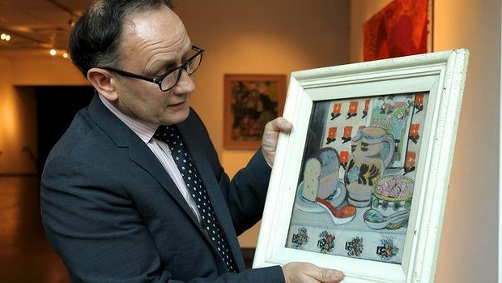

**image courtesy Sydney Morning Herald, 2014**

5.

4.

3.

2.

1.

**1. BRIDGET OHLSON  
*Still life*** 2004oil on canvas

**2. HELEN OGILVIE  
*Country slaughter house, Tasmania*** 1982oil on board  
  
**3. HELEN OGILVIE  
*Farm house Coonabarabran, NSW*** 1982oil on board   
  
**4. DAVID KIRK  
*Bay of fires*** 2010 charcoal on paper

**5. JOHN PASSMORE  
*Playing on the beach*** 1952ink on paper

8.

7.

6.

**6. KEN WHISSON  
*Untitled*** undated   
ink on paper

**7. KEN WHISSON   
*untitled*** undated   
ink on paper

**8. JOHN OLSEN  
*Bird and frog*** 1979lithograph

**INDIVIDUAL WORKS**

**VIVIAN FERGUSON  
*Saturday morning romance*** 1998 oil on canvas

**IAN HOWARD  
*Blinding force*** undated wood and collage

**MICHAEL STEVENSON  
*The accidental artist*** 1996charcoal on paper

**MICHAEL STEVENSON  
*J.P.S.*** 1991 oil on board

Collection: Henry Mulholland

**ANNE WALLACE  
*Untitled***  1997oil on paper

Collection: Henry Mulholland

**BOB EADIE  
*Wedding cake island, Coogee storm sea*** 1995oil on canvas

Collection: Henry Mulholland

**IAN SMITH  
*The call*** 1992oil on canvas

Collection: Henry Mulholland

**MICHAEL KEMPSON COLLECTION**

Michael Kempson (b. Kapunda, South Australia, 1961) is an artist, curator, master printer and academic currently living in Sydney. Kempson is a Senior Lecturer and Convenor of Printmaking Studies at the University of New South Wales Art & Design, a visiting Professor at the Xi’an Academy of Fine Art in China and the International Member at Large for the USA based Southern Graphics Council International for 2014 to 2016. He has been exhibiting in Australia since 1983 with a total of 26 one-person exhibitions and over 200 group exhibitions nationally and internationally. He was an invited artist in the *22nd International Biennial of Graphic Art* in Ljubljana (1997) and his most recent major international one–person exhibition was titled *Seen/Unseen – Michael Kempson/A Survey of Prints* at V.M. Art Gallery in Karachi, Pakistan (2010). In 2014 he was a commissioned artist for the Print Council of Australia Member Print and he was curated into *Kyoto Hanga 2014: Australia and Japan* at the Kyoto Municipal Museum in Japan. Kempson is represented in the Museum of Contemporary Art, Bangkok, Thailand; National Taiwan Museum of Fine Arts, Taipei; National Gallery of Australia, Canberra; The Art Gallery of New South Wales, Sydney; The Queensland Art Gallery, Brisbane; The Art Gallery of South Australia, Adelaide and many Australian regional galleries and corporate collections.

In addition Kempson initiates printmaking projects and has developed extensive connections in the Asia-Pacific region in his position as Director of Cicada Press, a research group at UNSW Art & Design. Through this educationally focussed custom-printing workshop he has worked with approximately 170 significant Australian and International artists and his curatorial experience has involved 51 exhibitions in Australia, Thailand, New Zealand, Taiwan, Pakistan, Korea, Japan, UAE, USA, Canada and China. These include: *Aboriginal Dreams – Paintings, Etchings, Linocuts – Indigenous Art from Papunya Tjupi,* atIndus Valley School of Art and Architecture, Karachi (2010); *Personal Space: Contemporary Chinese and Australian Prints* at Manly Art Gallery and Museum which toured Australian and Chinese galleries (2012/13); *Seoul-Sydney: Contemporary Korean and Australian Prints* at UNSW Galleries, Sydney (2014) and at Chugye University for the Arts, Seoul (2015); and *Interchange* at Silpakorn University Art Gallery, Bangkok, Thailand (2014) and touring to the Australian National University, Canberra and Mosman Art Gallery, Sydney (2015). Kempson was invited to curate an Australian exhibition representing UNSW for the *11th Annual Printmaking Exhibition and Conference for Chinese Academies and Colleges* at Guangzhou Academy of Fine Art in China (2012). This was the first invitation for an international art school to attend this prestigious event. Kempson convened the international panel for the *Southern Graphics Council International* conference titled *Bridges: Spanning Tradition, Innovation and Activism* in San Francisco, USA in March 2014 and will do so again at *Spheres* in Knoxville, Tennessee in 2015.

Michael Kempson is represented in Sydney by Flinders Street Gallery.

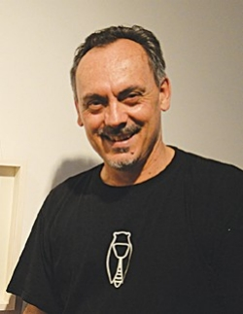

**image courtesy the University of Auckland, 2015**

5.

2.

1.

4.

3.

**1. DORIS BUSH NUNGARRAYI  
*Papa Tjukurrpa (dog dreaming) – Nyumannu*** 2010  
acrylic on canvas  
 **2. GUAN WEI  
*Under the South Cross*** 1999lithograph

**3. FREDDIE TIMS  
*Mud Springs*** 2000 aquatint

**4. BARBARA HANRAHAN  
*Birth*** 1986linocut   
  
**5. DICK FRIZZELL  
*Mickey to Tiki (reversed)*** 2012screenprint

13.

9.

8.

7.

12.

10.

6.

11.

**6. CHRIS O’DOHERTY aka REG MOMBASSA  
*Mambo pulp western – Osama Bill goes to Hollywood***  2001charcoal and coloured pencil

**7. KENNETH JACK  
*Young and Jacksons (Built 1875) from Old Melbourne Buildings*** 1961linocut

**8. GREGORY O’BRIEN  
*A memory of a filing card in the Elam Library, Auckland*** 2009 ink and watercolour

**9. KITTY KANTILLA  
*Jilamara #2*** 2001lithograph   
  
**10. ARTIST UNKNOWN  
*Untitled*** undated woodcut

**11. KEN CURRIE  
*Battlefield***  1991etching and aquatint   
  
**12.** **RAYMOND ARNOLD  
*Searching for immortality in the mountains – Mont Ventoux/After Petrarch 6th State*** 1998hard ground etching

**13.** **MINNIE NELSON NAKAMARRA  
*Sandhills and bush tomatoes at Kampurrarpa*** 2007acrylic on linen

21.

19.

17.

15.

14.

20.

18.

16.

**14. R. B. KITAJ  
*Articles and pamphlets from In Our Time: Covers for a Small Library After the Life for the Most Part*** 1969-70screenprint

**15. FRANCISCO GOYA  
*Alla va eso (there is goes) from Los Caprichos*** 1798etching and aquatint

**16. FRANCISCO GOYA  
*Hilan delgado (they spin finely) from Los Caprichos*** 1799etching and aquatint

**17. FRANCISCO GOYA  
*Yo lo vi (I saw this) from Los Desastres de la Guerra*** 1810-14etching and aquatint

**18. FRANCISCO GOYA  
*Lo mismo en ofras parte (the same elsewhere) from Los Desastres de la Guerra*** 1810-14etching and aquatint

**19. GLEN BAXTER  
*I sensed that Brenda was trying to impress me*** 1984lithograph

**20. WILLIAM HOGARTH  
*Scene in Bedlam from The Rake’s Progress – Plate 8*** 1735etching and engraving

**21. WILLIAM HOGARTH  
*The young hero takes possession of the Miser’s effects from The Rake’s progress – Plate 1*** 1735etching and engraving

**OBJECTS FROM LEFT TO RIGHT**

**LEX DICKSON  
*Square platter*** 2003shino and tenmoku glazed ceramic

**LEX DICKSON  
*Square platter*** 2005shino and tenmoku glazed ceramic

**INDIVIDUAL WORKS**

**ROGER KEMP  
*Sequence 13*** 1975etching

Collection: Michael Kempson

**IDRIS MURPHY  
*Title*** undatedmedium

Collection: Michael Kempson

**FRED WILLIAMS  
*Chopped trees*** 1965-6etching

Collection: Michael Kempson

**ALUN LEACH-JONES  
*City life #2*** 1995 screenprint

Collection: Michael Kempson

**AKIRA KUROSAKI  
*Traces of time*** 1981woodcut

Collection: Michael Kempson

**BRIAN BLANCHFLOWER  
*Nocturne*** 1999aquatint

Collection: Michael Kempson

**LLOYD REES  
*Timeless cliffs*** 1980lithograph

Collection: Michael Kempson

**FIONA HALL  
*Bloodline*** 2000photo-lithograph

Collection: Michael Kempson

**EUAN MACLEOD  
*Figure facing forwards and backwards*** 2003oil on canvas

Collection: Michael Kempson

**EARLE BACKEN  
*Still life – Jerusalem*** 1983oil and acrylic on canvas

Collection: Michael Kempson

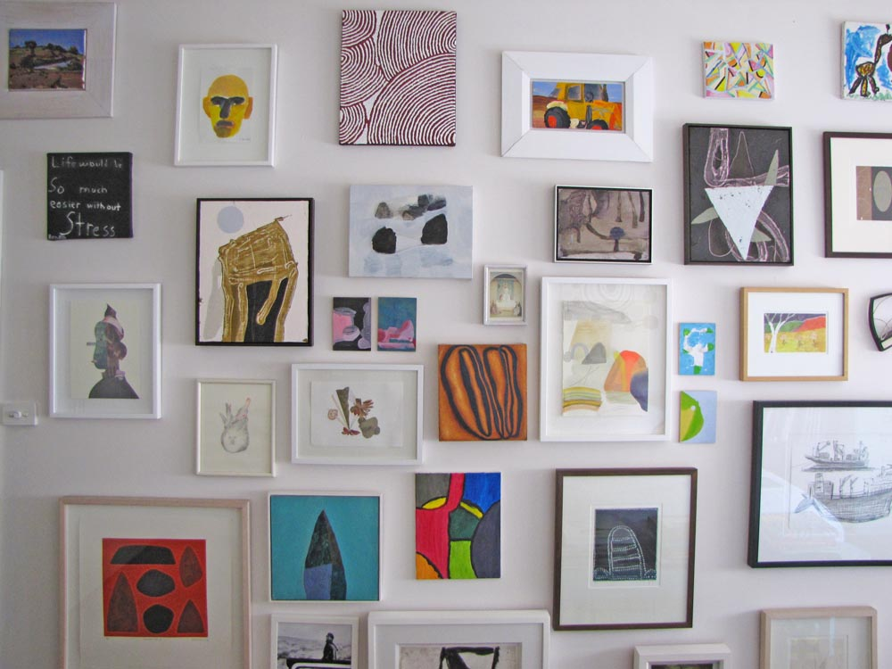





For exclusive insider-updates, behind the scenes looks, and industry news, follow us on **Instagram** (@shervingallery) and **Facebook** (The National Trust SH Ervin Gallery)

**Watson Road, Observatory Hill, The Rocks, Sydney**  
**Gallery Front Desk Ph:** (02) 9258 0173

**Gallery Hours:** Tuesday – Sunday 11am-5pm

**Sunday afternoons @ the Gallery – Special guest talks selected Sundays at 3pm   
Admission: $7 General / $5 Concessions / $4 National Trust members / Children under 12 free**

Please be aware that for copyright and conservation reasons the S.H. Ervin Gallery **does not permit the use of photographic devices (digital, video, film or mobile phone cameras), with or without flash**, inside the exhibition space.